Experiment -12
Installation of Type-2 Hypervisor and Creation of a Virtual Machine
Aim
To demonstrate virtualization by installing a Type-2 hypervisor and creating and configuring a virtual machine. Procedure
- Download and install VMware Workstation on the Windows host operating system.
- Open VMware Workstation and select File → New Virtual Machine.
- Select Typical (recommended) and click Next.
- Choose the Ubuntu ISO image or select the option to install the operating system later.
- Select Linux as the guest operating system and Ubuntu as the version.
- Enter the virtual machine name as Ubuntu and specify the location to store the virtual machine files.
- Configure the virtual machine with 1 processor, 2 GB RAM, and a 15 GB virtual hard disk.
- Configure the virtual hard disk by specifying the maximum storage capacity and selecting the required disk storage option.
- Configure the network adapter using NAT to enable network access through the host system.
- Review the configuration and click Finish to create the virtual machine.
- Power on the virtual machine and install Ubuntu by following the on-screen instructions.
- After installation, restart the virtual machine and verify that Ubuntu runs successfully inside VMware Workstation.

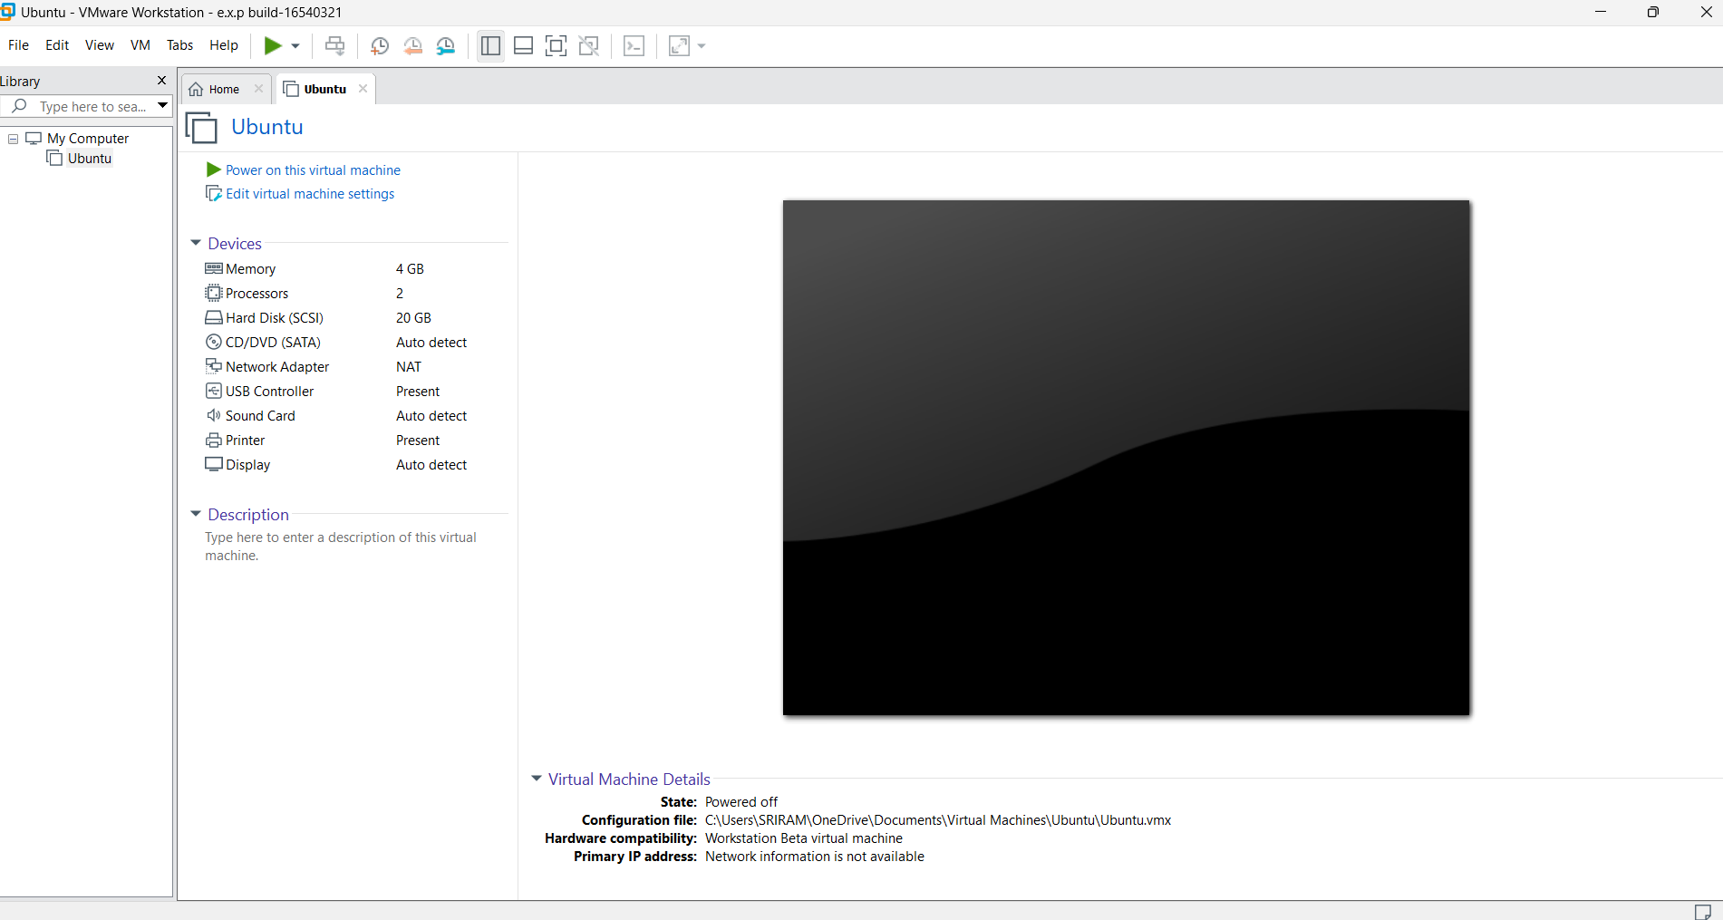

Output:

Result

Thus, virtualization was successfully demonstrated by installing VMware Workstation, a Type
-
2
hypervisor, and creating and configuring a virtual machine with Ubuntu Linux as the guest
operating system on a Windows host.

